**Hayward Research Project Update Friday 31st May**

I used glmmTMB for my models last week, which uses Template Model Builder (TMB) and is apparently faster than the glmer that I was taught to use in my data science course, providing better performance and stability for large datasets and complex models. glmer models are simpler and I am more familiar with it so I’ve tried using university computers to run the same models but with glmer(). Each of these models take over 20 minutes to run with the university computer. The glmer models gave different and sometimes results that were in different directions from the glmmTMB models.

I am not sure which function I should stick to, the glmmTMB is faster and more suitable for large datasets and complex models from my understanding. I had also encountered convergence issues with all of my glmer models and glmmTMB is supposed to be a more robust alternative in such situation. The glmmTMB models also provide lower AIC values than glmer models across all tested models. However, I’m not familiar with the package and even after some research, I’m uncertain whether or not this is the most suitable package to use in this situation.

R also suggested scaling the numeric predictors to deal with the large eigenvalue so I used the scale() function for the density measure, mum age squared and birth weight when applicable, and I ran all the models again using the scaled data. Although all the coefficients using scaled data were negative and the values were much higher, half of the models ended up being insignificant.

Out of the 8 different models for each density measure, Hinds had the lowest AIC values on 7 of them (2nd lowest for the scaled glmer model with no birth weight). 7 of the Hinds models were also significant with the exception of the glmer model.

Additional notes:

1. I also extracted the data for first year spike lengths and can start modelling once I finalised which package to use for the modelling.
2. I did a quick search for papers on mother status and involving birth weight but couldn’t find anything. Will try and keep looking for a bit longer.

Questions:

1. Which model would you recommend using? Perhaps there are other models that you would recommend instead?
2. For Fecundity, should I be using the percentage of Hinds that produce an offspring per year?

Anyway, I’ve attached all of the model results below, including those from last week.

**Screenshots of glmmTMB in black**

**Screenshots of glmer in white**

**Summary**

**Yellow = insignificant**

|  |  |  |  |  |
| --- | --- | --- | --- | --- |
|  | **glmer** | **glmmTMB** | **glmer**  **No Birthwt** | **glmmTMB**  **No Birthwt** |
| **Hinds** | **-0.52 (p=0.185)** | **-0.92 (p=1.39e-13)** | **-0.19 (p=1.01e-5)** | **-0.22 (p=0.027)** |
| **Adults** | **-0.15 (p=0.0183)** | **-0.24 (p=0.163)** | **-0.063 (p=0.648)** | **-0.23 (p=0.017)** |
| **Total** | **0.087 (p<2e-16)** | **-0.60 (p=8.58e-14)** | **-0.082 (p<0.0005)** | **-0.20 (p=0.02)** |
| **LU_Total** | **0.29 (p<2e-16)** | **-0.68 (p=0.0145)** | **-0.15 (p<2e-16)** | **-0.50 (p=0.32)** |

**AIC**

|  |  |  |  |  |
| --- | --- | --- | --- | --- |
|  | **glmer** | **glmmTMB** | **glmer**  **No Birthwt** | **glmmTMB**  **No Birthwt** |
| **Hinds** | **509.3555** | **489.5808** | **1514.532** | **1464.844** |
| **Adults** | **518.3788** | **500.5656** | **1527.962** | **1467.981** |
| **Total** | **524.9928** | **495.9875** | **1516.331** | **1468.688** |
| **LU_Total** | **523.1475** | **500.8891** | **1525.495** | **1469.664** |

**Scaled (Yellow = insignificant)**

|  |  |  |  |  |
| --- | --- | --- | --- | --- |
|  | **glmer** | **glmmTMB** | **glmer**  **No Birthwt** | **glmmTMB**  **No Birthwt** |
| **Hinds** | **-11.98 (p=6.78e-7)** | **-21.5 (p=1.37e-13)** | **-4.14 (p<2e-16)** | **-5.18 (p=0.0274)** |
| **Adults** | **-2.578 (p=0.567)** | **-7.96 (p=0.009)** | **-0.137 (p<2e-16)** | **-7.09 (p=0.0168)** |
| **Total** | **-4.793 (p=0.122)** | **-10.3 (p=0.110)** | **-1.424 (p=0.481)** | **-6.84 (p=0.0205)** |
| **LU_Total** | **-2.148 (p=0.565)** | **-7.14 (p=0.108)** | **-1.785 (p=0.418)** | **-6.08 (p=0.317)** |

**Scaled AIC**

|  |  |  |  |  |
| --- | --- | --- | --- | --- |
|  | **glmer** | **glmmTMB** | **glmer**  **No Birthwt** | **glmmTMB**  **No Birthwt** |
| **Hinds** | **508,9413** | **489.5808** | **1519.737** | **1464.844** |
| **Adults** | **518.6005** | **500.4084** | **1545.983** | **1467.981** |
| **Total** | **530.7515** | **498.3281** | **1557.594** | **1468.688** |
| **LU_Total** | **528.3578** | **501.1892** | **1505.954** | **1469.664** |

**Hinds only**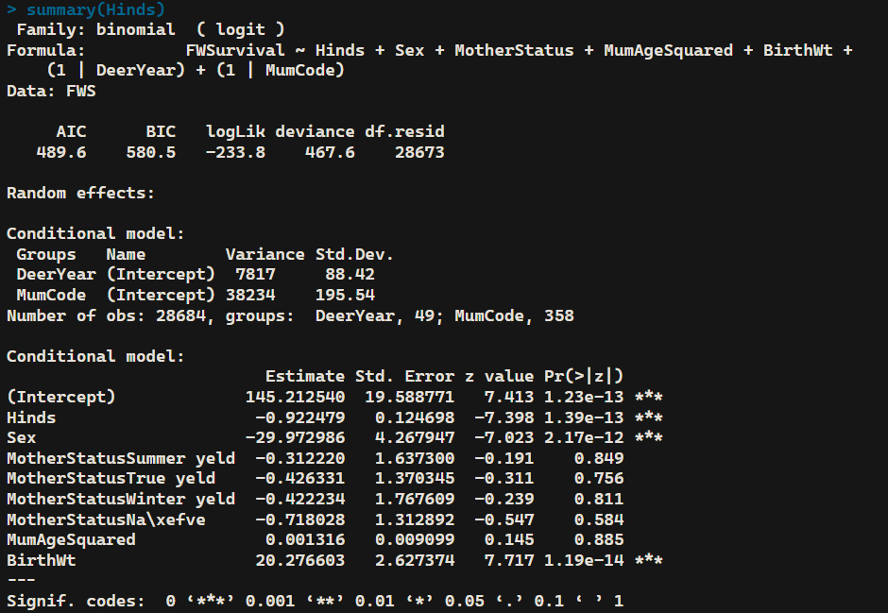

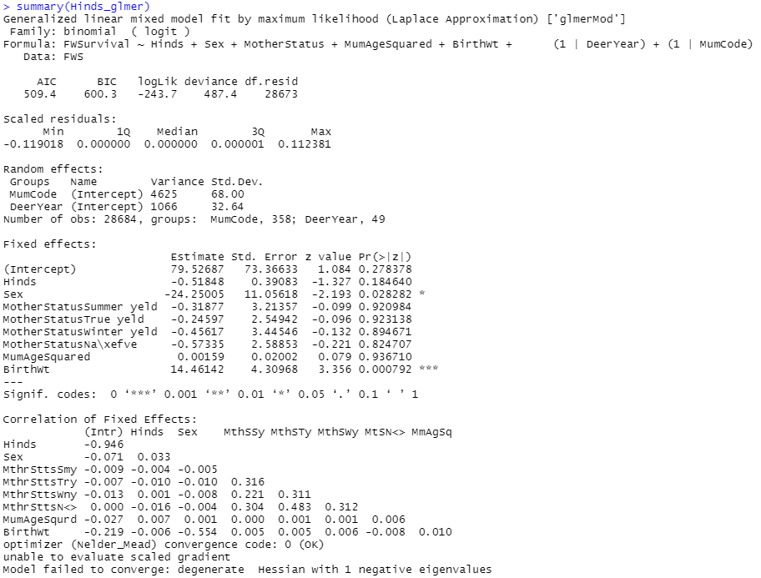

**Hinds+Stags**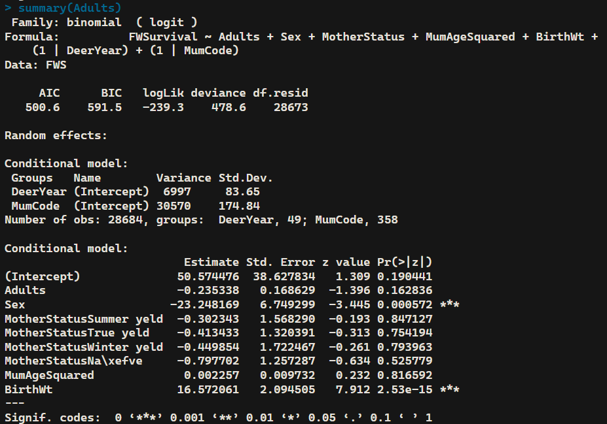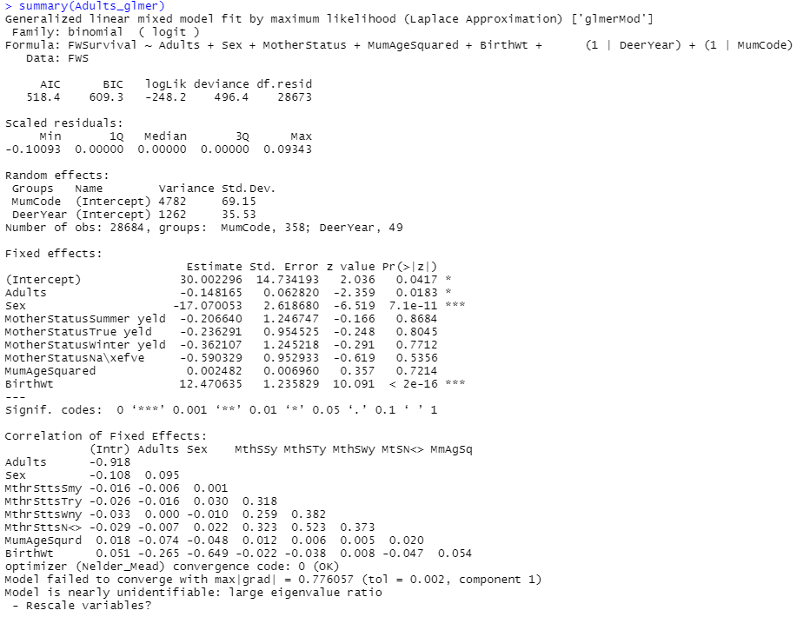

**Hinds+Stags+Calves**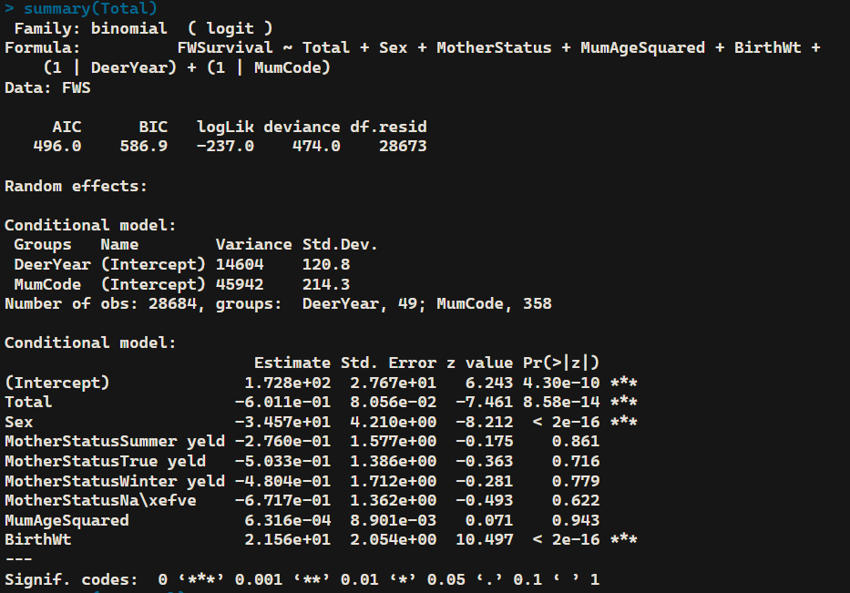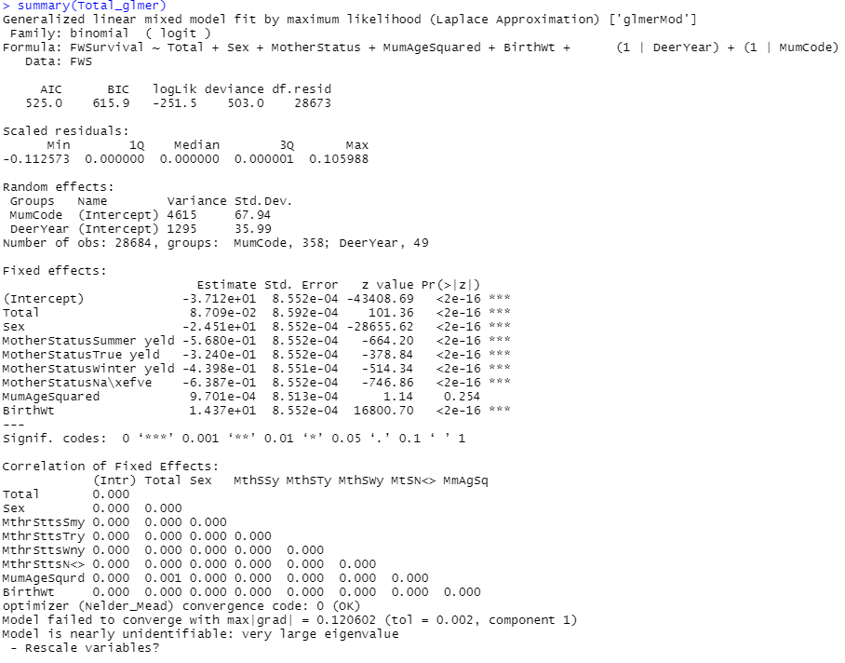

**Livestock units**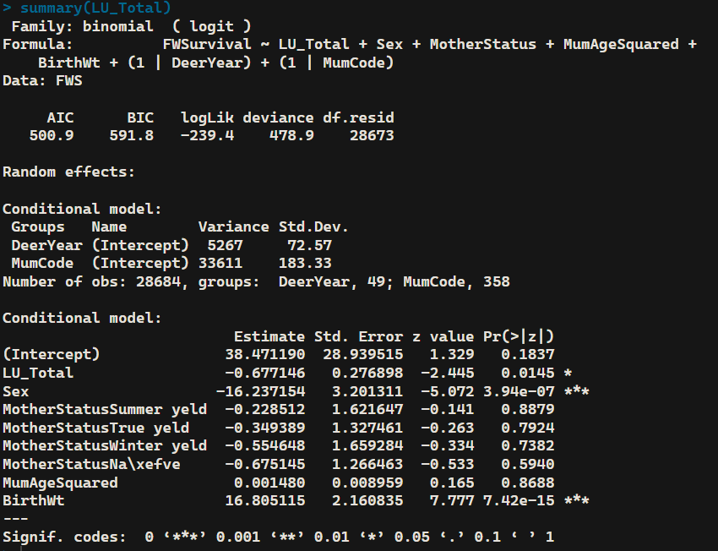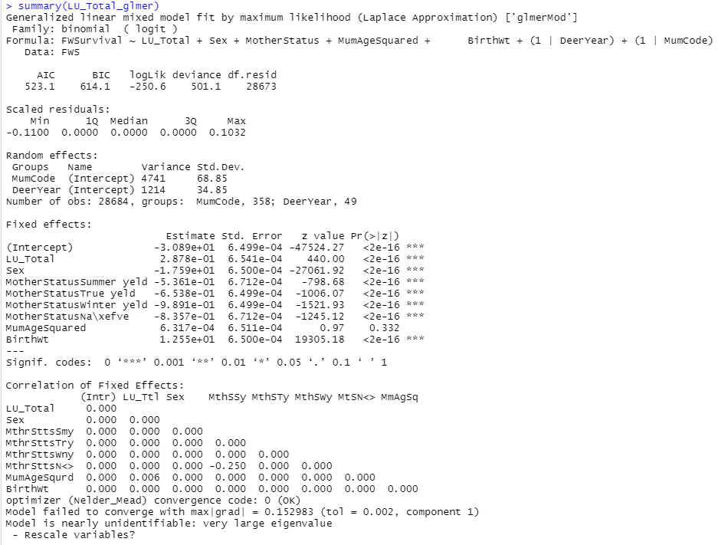

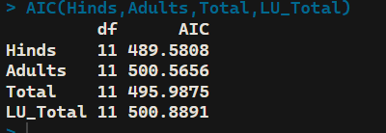

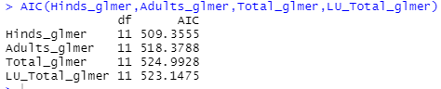

The glmmTMB models seemed to have lower AIC than glmer models.

glmmTMB models using Hinds, Total and Livestock units showed significant negative coefficients for the density measures. Model using adults (hinds+stags) was negative too but insignificant.

glmer models using hinds and adults both resulted in negative coefficients but only the one for adults was significant. Model including calves (total) and using livestock units were significant but had a positive coefficient.

**Hinds only without birth weight**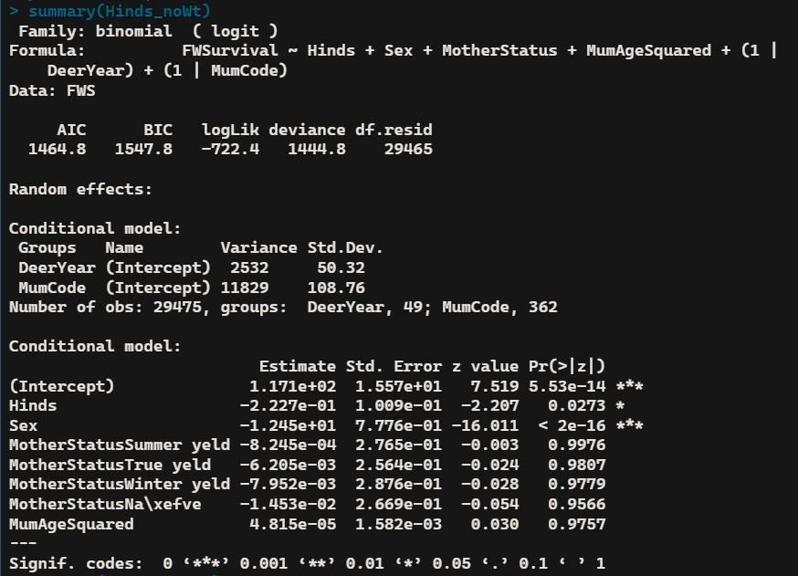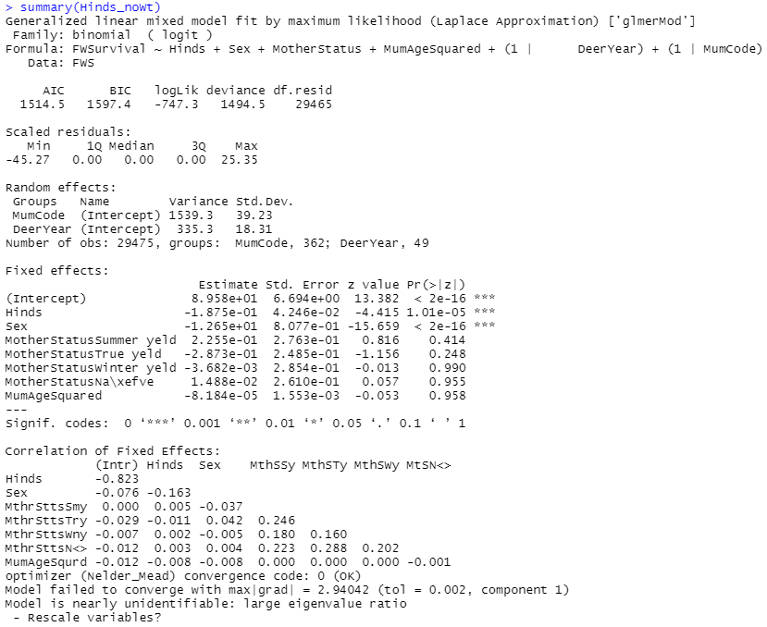

**Hinds+Stags without Birth Weight**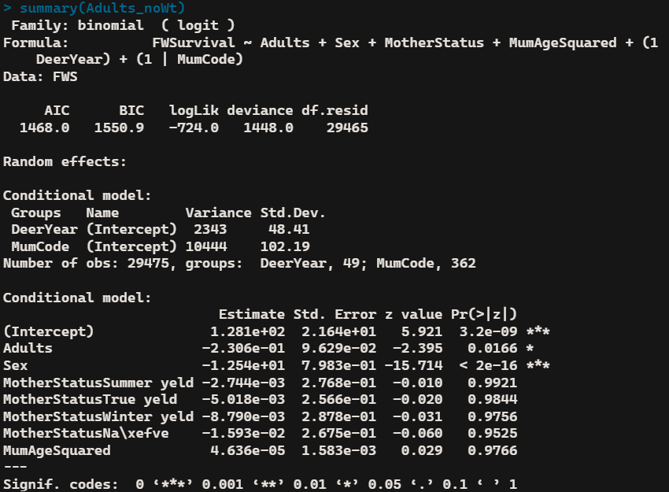

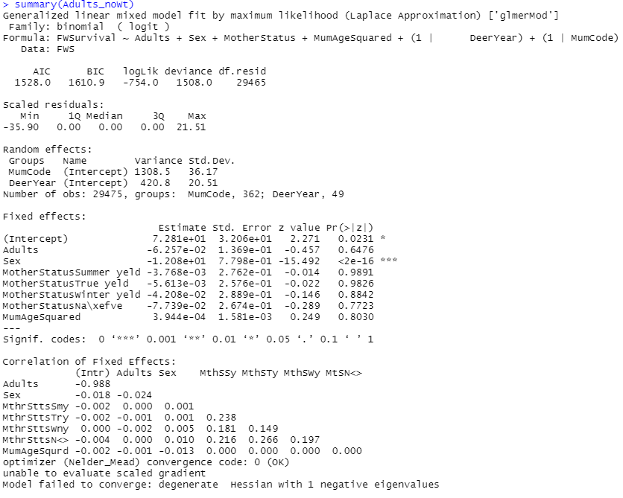

**Hinds+Stags+Calves without Birth Weight**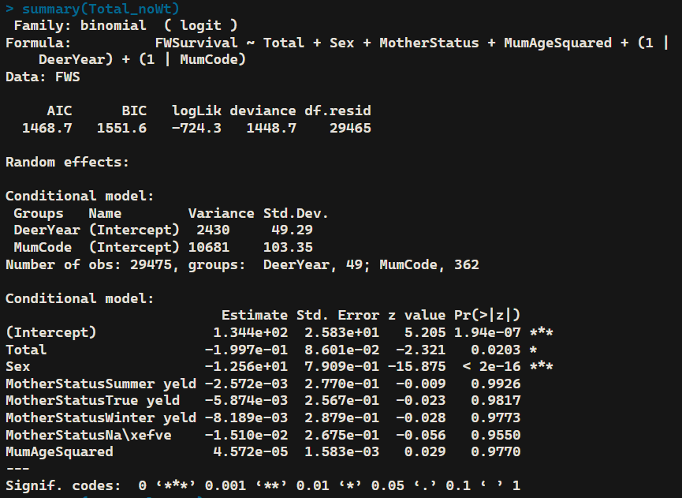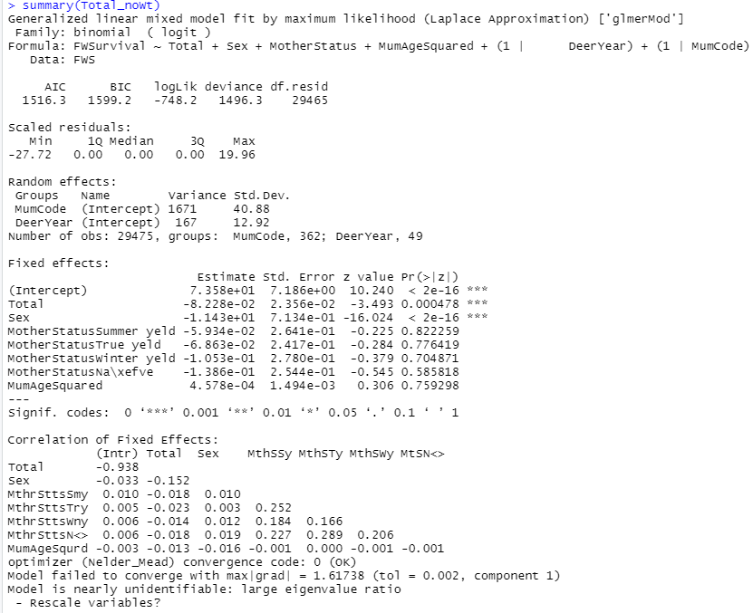

**Livestock Units without Birth Weight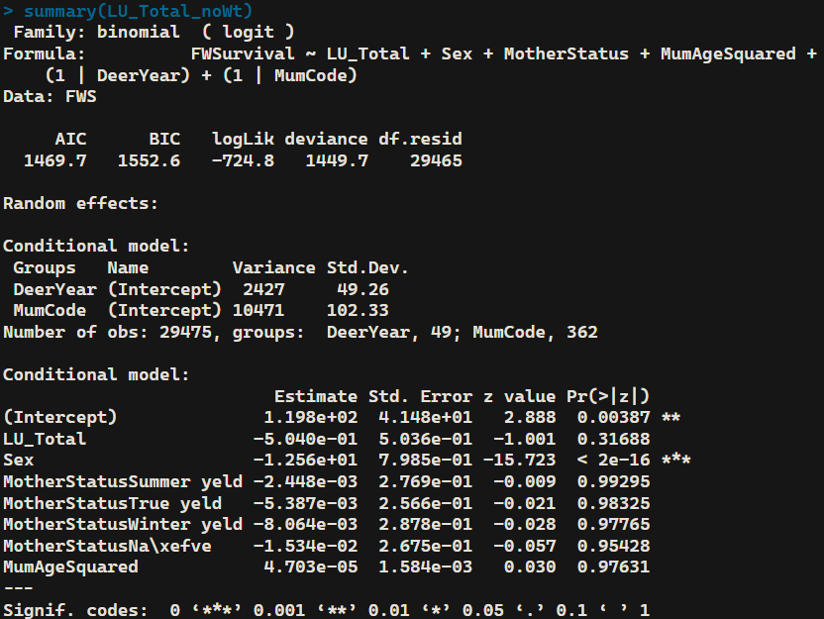**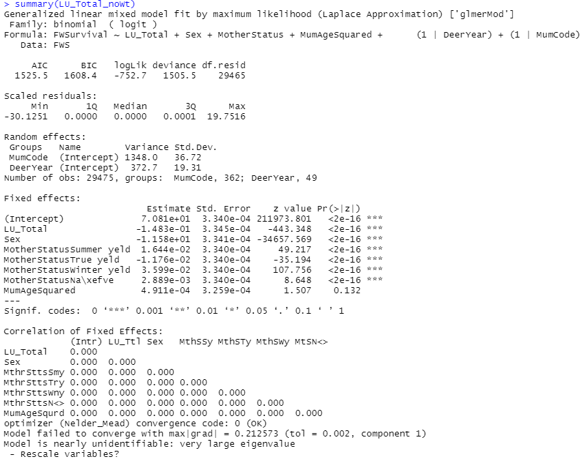

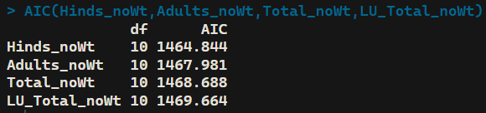

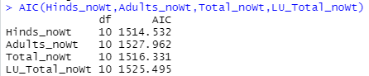

When excluding birth weight, the glmmTMB models still had lower AIC than glmer models but they were all much higher than the models including birth weight.

All the glmmTMB models showed negative coefficients for the density measures but the model using livestock units was insignificant.

All the glmer models showed negative coefficients for the density measures but the model for Adults was insignificant.

Scaled Hinds glmmTMB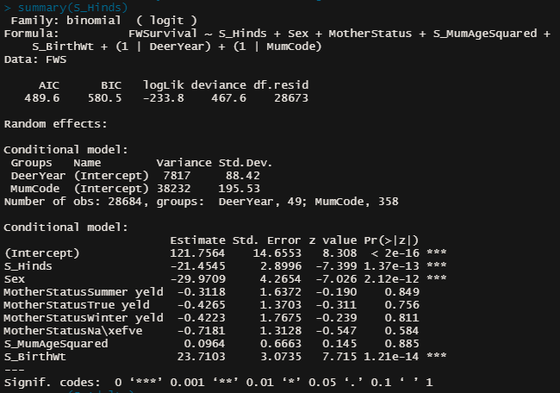

Scaled Adults glmmTMB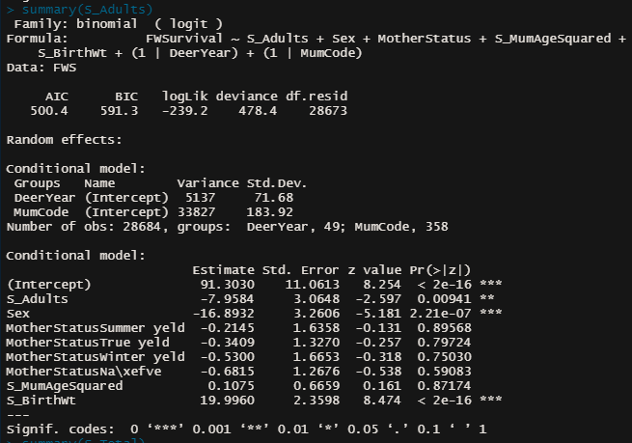

Scaled Total glmmTMB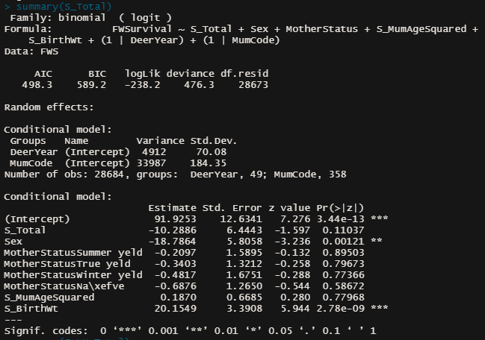

Scaled LU_Total glmmTMB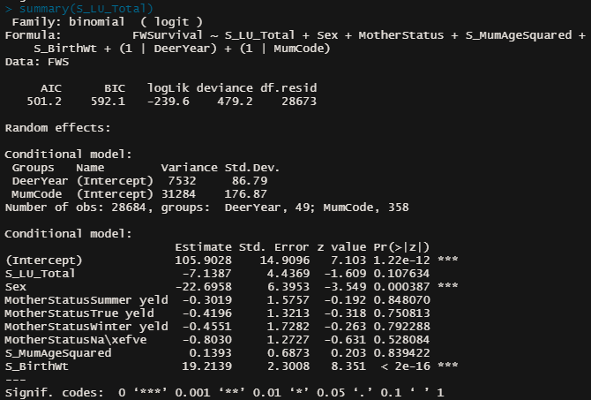

AIC for scaled glmmTMB

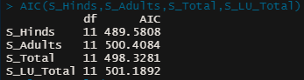

When excluding birth weight, the glmmTMB models still had lower AIC than glmer models but they were all much higher than the models including birth weight.

All the glmmTMB models showed negative coefficients for the density measures but the model using livestock units was insignificant.

All the glmer models showed negative coefficients for the density measures but the model for Adults was insignificant.

Scaled Hinds glmer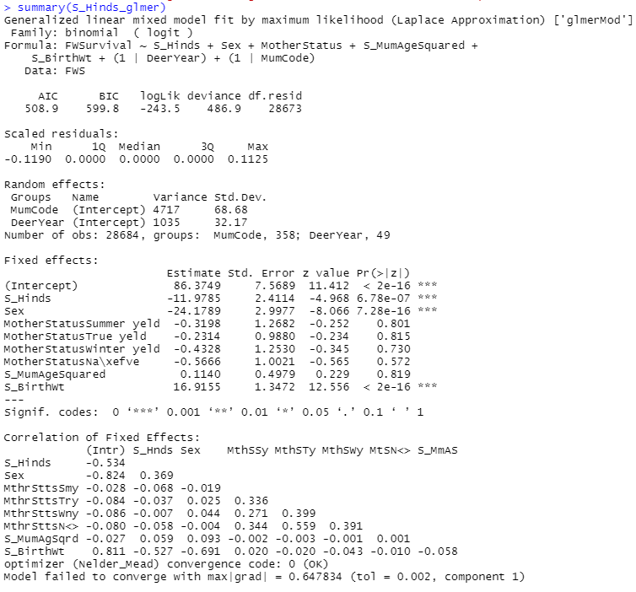

Scaled Adults glmer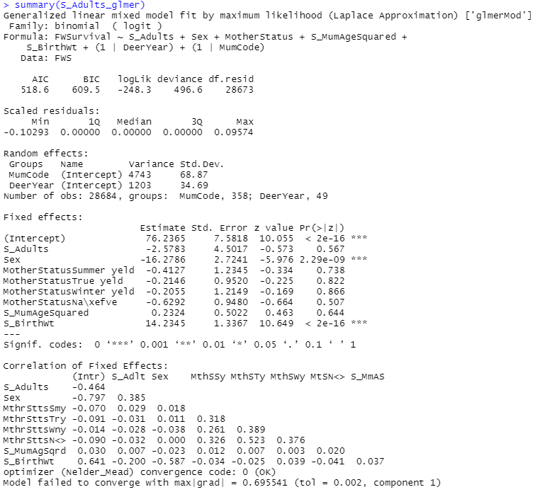

Scaled Total glmer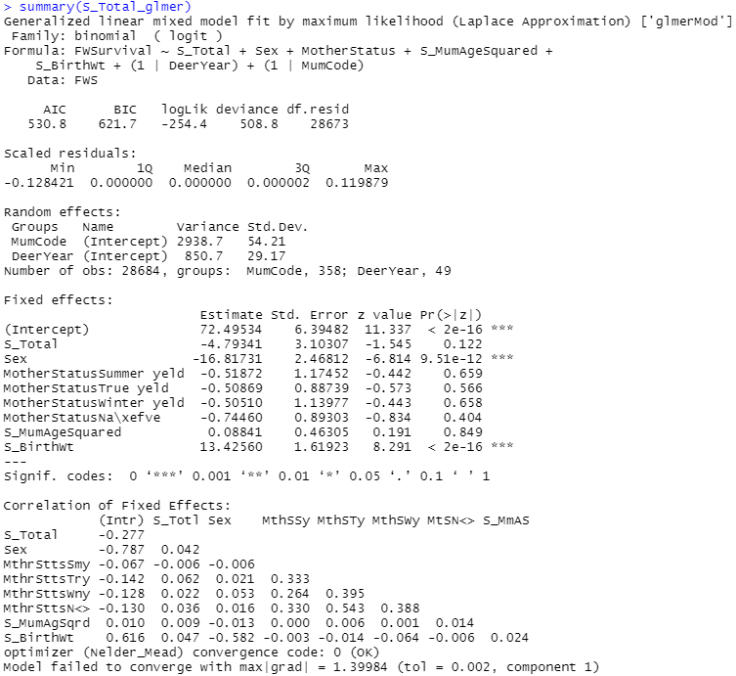

Scaled Livestock units glmer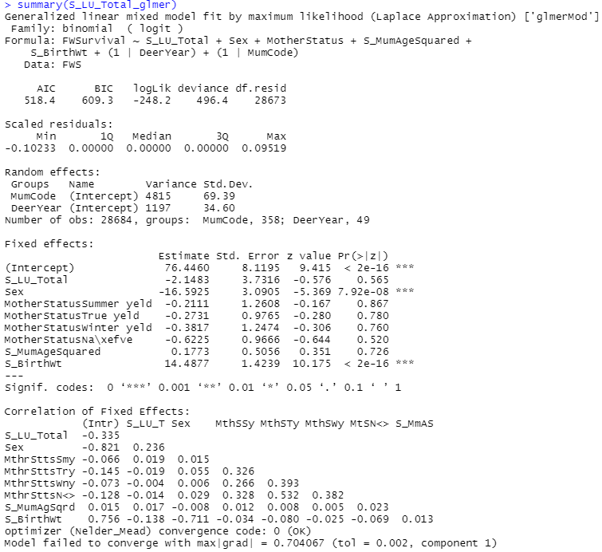

AIC for scaled glmer

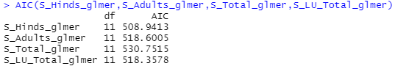

Scaled Hinds without Birth Weight glmmTMB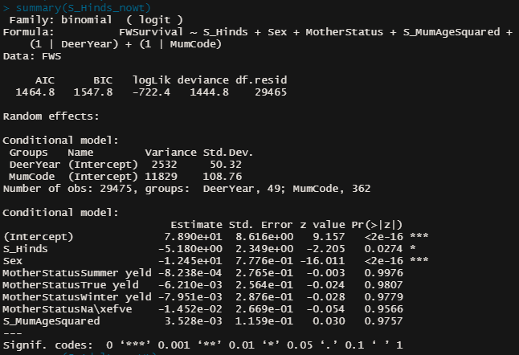Scaled Hinds without Birth Weight glmer

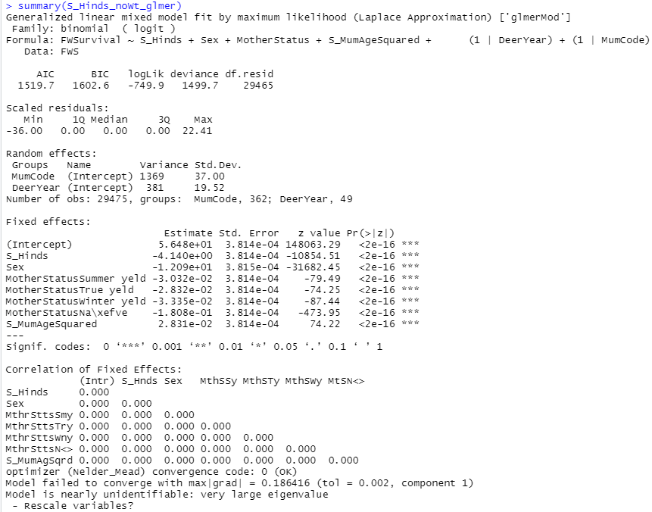

Scaled Adults without Birth Weight glmmTMB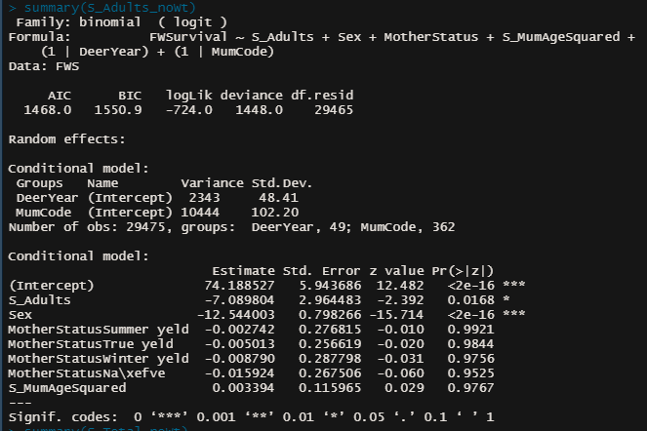Scaled Adults without Birth Weight glmer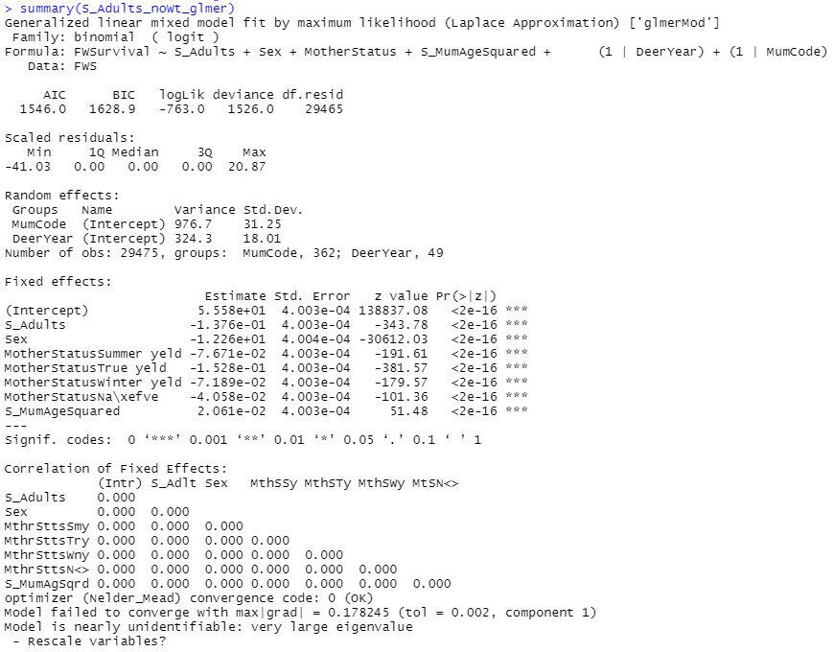

Scaled Total without Birth Weight glmmTMB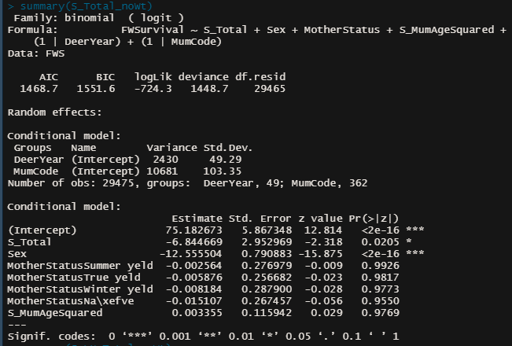Scaled Totla without Birth Weight glmer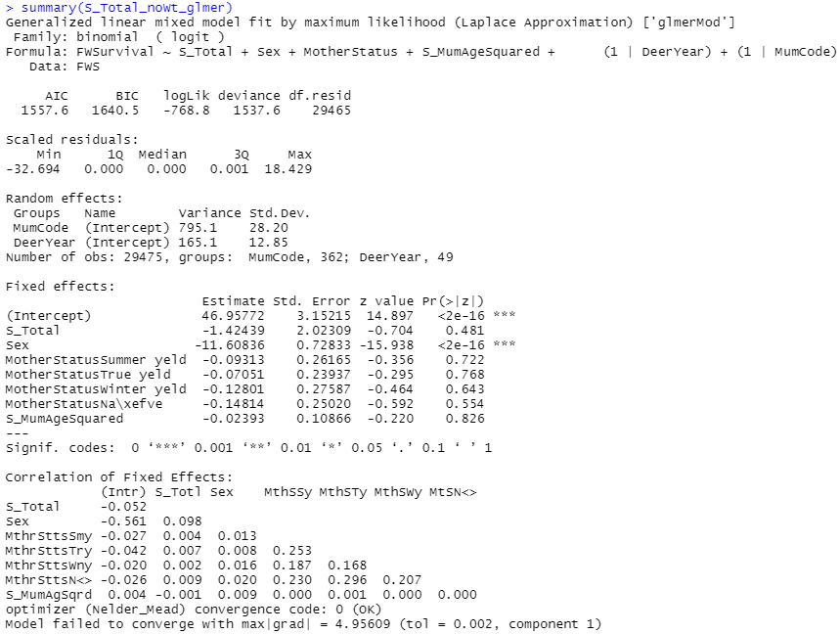

Scaled Livestock Units without Birth Weight glmmTMB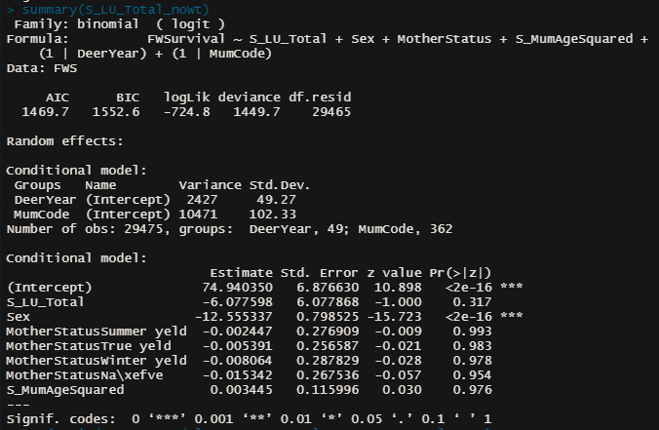Scaled Livestock units without Birth Weight glmer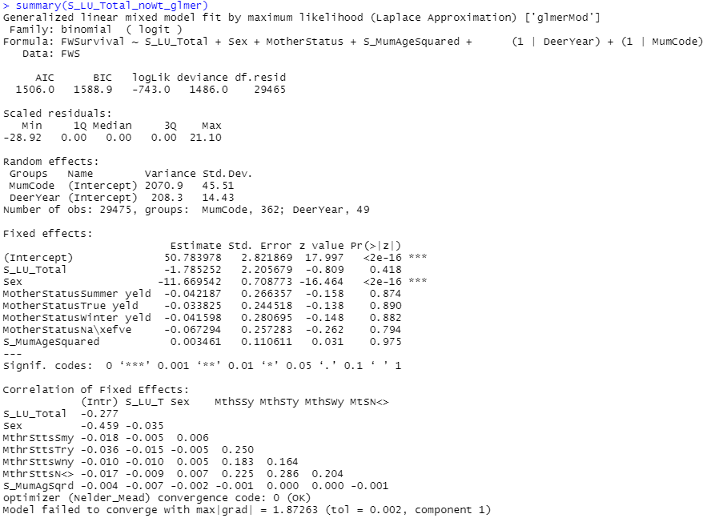

AIC for Scaled models without birth weight using glmmTMB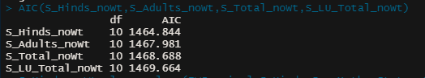

AIC for Scaled models without birth weight using glmer

